EXPERIMENT – 6
NAME: S.NITHISH KUMAR ROLL NO:240701817

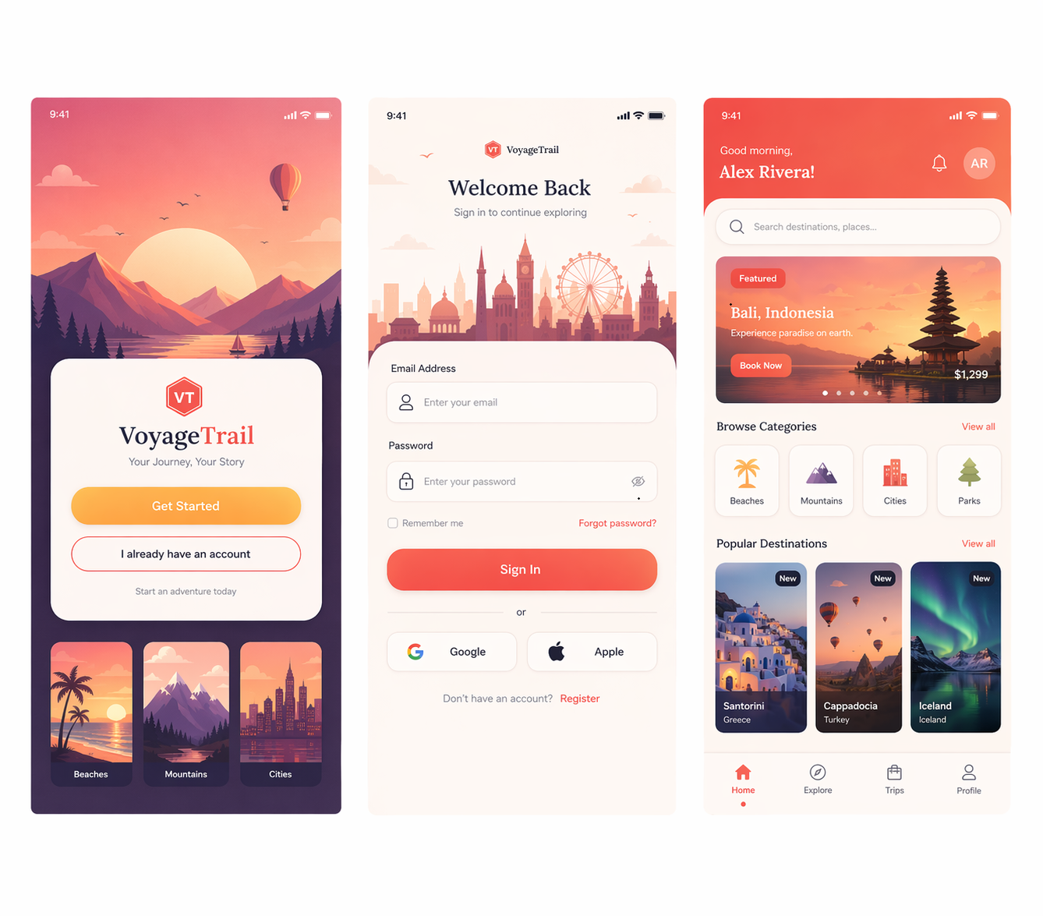

App Name
VoyageTrail
Tagline: Explore more. Travel deeper.

Light Mode (Description)
- Warm & Inviting Feel
Uses sunset-inspired tones like coral, peach, and soft orange to create a welcoming travel vibe.
- Bright Backgrounds
Off-white and light beige backgrounds improve readability and give a clean, airy interface.
- Soft Gradients
Gradients (orange → coral) are used in headers, banners, and buttons to add depth without overwhelming the UI.
- High Readability
Dark text on light surfaces ensures clarity for forms, labels, and navigation.
- Friendly UI Elements
Rounded cards, soft shadows, and pastel illustrations make the experience approachable and relaxed.
- Vibrant Visual Cards
Destination cards use colorful imagery to evoke excitement and wanderlust.
- Clear Call-to-Actions
Buttons (e.g., “Get Started”, “Sign In”) use bold coral tones to stand out and guide users.

Dark Mode (Description)
- Premium & Modern Look
Deep navy, indigo, and charcoal backgrounds create a sleek and high-end feel.
- Reduced Eye Strain
Designed for low-light usage with softer contrasts and muted backgrounds.
- Neon Accent Highlights
Bright accent colors like magenta, purple, and electric blue make key elements pop.
- Glowing Gradients
Buttons and highlights use subtle glow effects (purple → pink gradients) for a futuristic touch.
- Enhanced Visual Focus
Content like destination cards and images stand out more vividly against dark backgrounds.
- Minimal Distractions
Reduced brightness and cleaner contrast help users focus on essential actions and content.
- Consistent UI Structure
Same layout as light mode, but adapted colors ensure familiarity while offering a different mood.

